Dear Neighbors,
Myotonic dystrophy is a rare, genetic, multi-system disease that can make life really challenging for the people who have it and the families who love them - and this disease affects families right here in our neighborhood! Myotonic dystrophy can affect every part of the body: the brain, heart, muscles, gastrointestinal tract, vision, hormones, and more. It is the most common form of adult muscular dystrophy and can impact the ability to move, think, and breathe but there is currently no cure and no treatment. It’s genetic, with fifty-fifty odds of a child inheriting the gene from an affected parent, and this disease has a unique trait: symptoms usually get worse from generation to generation. More research and clinical education are needed and more people need referrals to good medical care!
To help change this, I am raising awareness about this disease and I am asking you to help me!
To help raise awareness about myotonic dystrophy, the Myotonic Dystrophy Foundation and forty other members of a Global Alliance have declared September 15th International Myotonic Dystrophy Awareness Day, and I am asking you to join the movement!
What you can do to help:
All you have to do is post the enclosed flyer somewhere visible so that other neighbors can learn about myotonic dystrophy. That’s it! By giving one single 8.5x11 inches of space on your home or business, you could help just one other person learn about myotonic dystrophy, and that one person may tell someone else, who may tell someone else…
Your generous act of posting this information may help lead to earlier diagnoses, a donation that funds research, or even a decision by a medical student to research and one day find a cure for myotonic dystrophy!
So please, dear neighbor, hang up the enclosed flyer in a public place and join our movement to raise awareness about myotonic dystrophy.
Thank you so much for your support!!
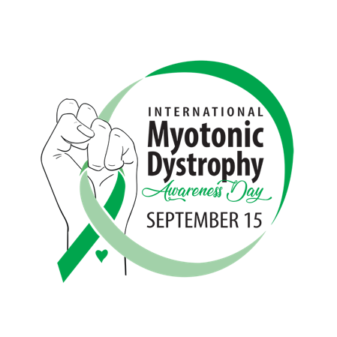
Learn more & support the cause at https://www.myotonic.org/international-dm-day

