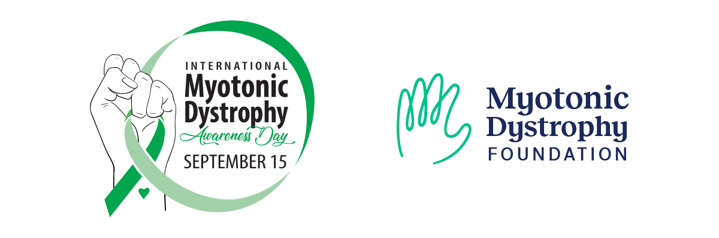

Email your Senator to Support S.Res.336
Subject:
Please support S.Res.336 for International Myotonic Dystrophy Awareness Day

Message:

I am a constituent who lives in TOWN, STATE and I have / have a loved one living with myotonic dystrophy. As a volunteer advocate with the Myotonic Dystrophy Foundation, I am writing to urge you to co-sponsor Senate resolution S.Res.336, recently introduced by Senator Tim Kaine (D-VA) to recognize September 15th as International Myotonic Dystrophy Awareness Day.

Myotonic dystrophy is a multi-systemic inherited genetic disease that affects an estimated 1 in 2,100 people or over 150,000 individuals in the United States. The disease is caused by a mutation in a gene required for normal muscle function which prevents the gene from carrying out its function properly. Individuals affected by myotonic dystrophy may have skeletal muscle problems, heart function abnormalities, breathing difficulties, cataracts, issues with speech and swallowing (dysarthria and dysphagia), cognitive impairment, excessive daytime sleepiness, or diabetic symptoms. It causes disability and can reduce life expectancy. Myotonic dystrophy is considered the most variable disease in medicine. There are currently no Food and Drug Administration (FDA) approved treatments for myotonic dystrophy, and federal funding for myotonic dystrophy has lagged behind other disorders with a similar genetic base.

You can learn more about myotonic dystrophy at https://www.myotonic.org/myotonic-dystrophy-glance

Establishing September 15th as International Myotonic Dystrophy Awareness Day this year will increase awareness and funding for myotonic dystrophy research that will improve health outcomes, reduce disability, and increase life expectancy for individuals living with the disease. Several other legislative bodies are considering similar resolutions across the globe and Senate passage of this resolution will help spread global awareness and activism. We urge you to co-sponsor this important resolution and appreciate your support.

Learn more about International Myotonic Dystrophy Awareness Day at https://www.myotonic.org/international-dm-day

I appreciate your kind attention to this request and look forward to your reply.

Sincerely,
YOUR NAME

