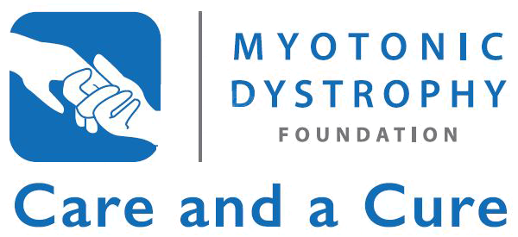

[Your name]
[Address]
[City, State, ZIP]

The Honorable [Name]
[Address]
[City, State, ZIP]

[Date]

Dear [Representative or Senator] [Last Name],

My name is [your name], and I am writing to you on behalf of the myotonic dystrophy community. As a person [living with/caring for a friend/relative] with myotonic dystrophy, I am writing to express my strong support for congressional action on the bipartisan 21st Century Cures Act (H.R. 6), unanimously passed by the House Energy & Commerce Committee on May 21.

Myotonic dystrophy (DM) is the most common form of adult-onset muscular dystrophy and is the only form that has impacts on cognition and brain function, in addition to impacts on the heart, lungs, muscles, gastrointestinal system, and many other parts of the body. Because DM affects many different parts of the body, symptoms can vary widely and it is significantly under-diagnosed. The congenital and juvenile-onset forms of this disease are particularly devastating. As a genetic disease, it impacts entire families and becomes more severe with each successive generation.

As a rare disease, it is estimated that between 1:3,000 to 1:8,000 people – as many as 100,000 Americans – are living with DM, and there are no treatments or a cure for this disease. Therefore it is critically important that Congress support this bipartisan effort that seeks to modernize and personalize health care, encourage greater innovation, support research, and streamline the system to deliver better, faster cures to more patients.

On September 18-19th, the Myotonic Dystrophy Foundation will be hosting its annual meeting in Washington, DC. Hundreds of individuals living with DM and their families will attend, seeking support and increased funding for NIH research, access to care, and the 21st Century Cures Act. As the House and Senate prepare to consider this vital piece of legislation, I hope that our community can count on your support.

Sincerely,

[Your name]

